**United States International University Africa  
Nairobi, Kenya  
APT2022-Introduction To Assembly Programming**

**PRACTICAL LAB I: 8086 Microprocessor Kit and 8086 Pin Diagram**

**INSTRUCTIONS AND ACTIVITIES**

1. Study the given 8086 microprocessor kit picture of Fig.1.1 and other associated components.

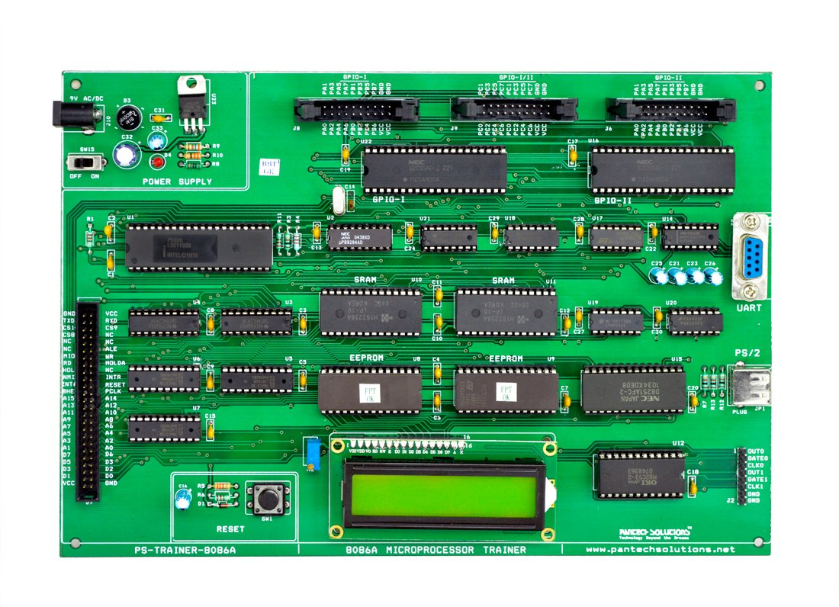

Fig.1 8086 kit picture

1. Identify the components, one by one; in terms of their location in the kit and what purpose they serve. In the photo, label the parts identified, serially e. g part 1, Part 2, etc.
2. Briefly outline the functions of the identified parts in the report write up. For example
3. Part 1: p8086A-2-**Central Processing Unit (CPU)**: This performs arithmetic and logical operations on the data and serves as the “brain” of the computer.
4. Part 2: **Random Access Memory (RAM)………………………...**

4. Identify the 8086 microprocessor chip pins shown in Fig. 2 and give their functions.

5. The group reports are to be submitted via blackboard link provided within the deadline indicated and must be written according to the template discussed in class.

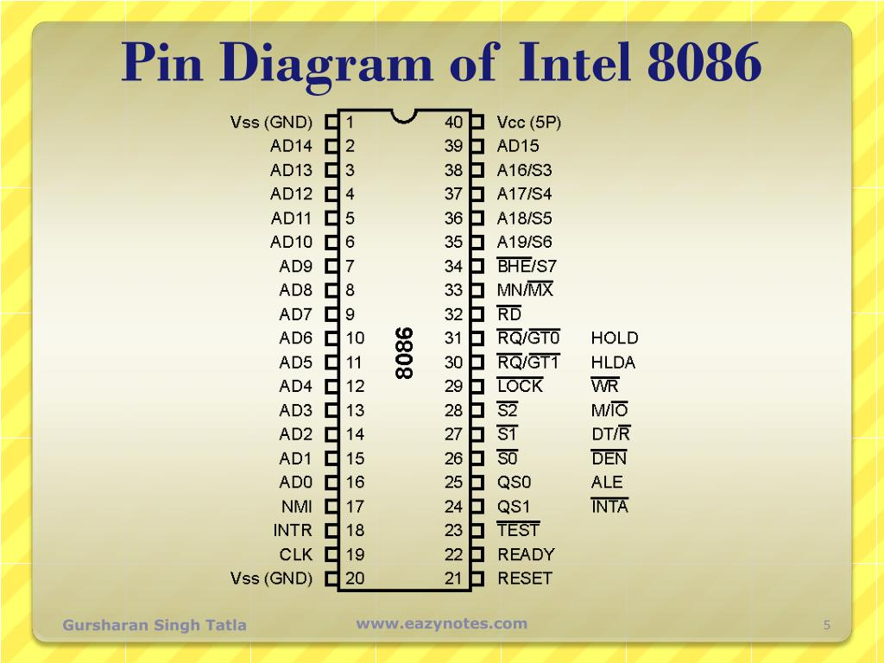

Fig.2 8086 Microprocessor Pin Diagram

**QUESTIONS**

1. Distinguish between the minimum mode and maximum mode of 8086 Microprocessor.

2. Comment on the use of 8086 microprocessor kit and 8086 Emulator.

* An 8086 microprocessor makes operations like multiplication and division easy because it has a powerful instruction set

You may find the following information in Fig.3 and Fig.4. useful.

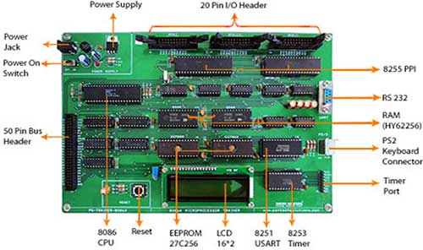

Fig.3 8086 kit

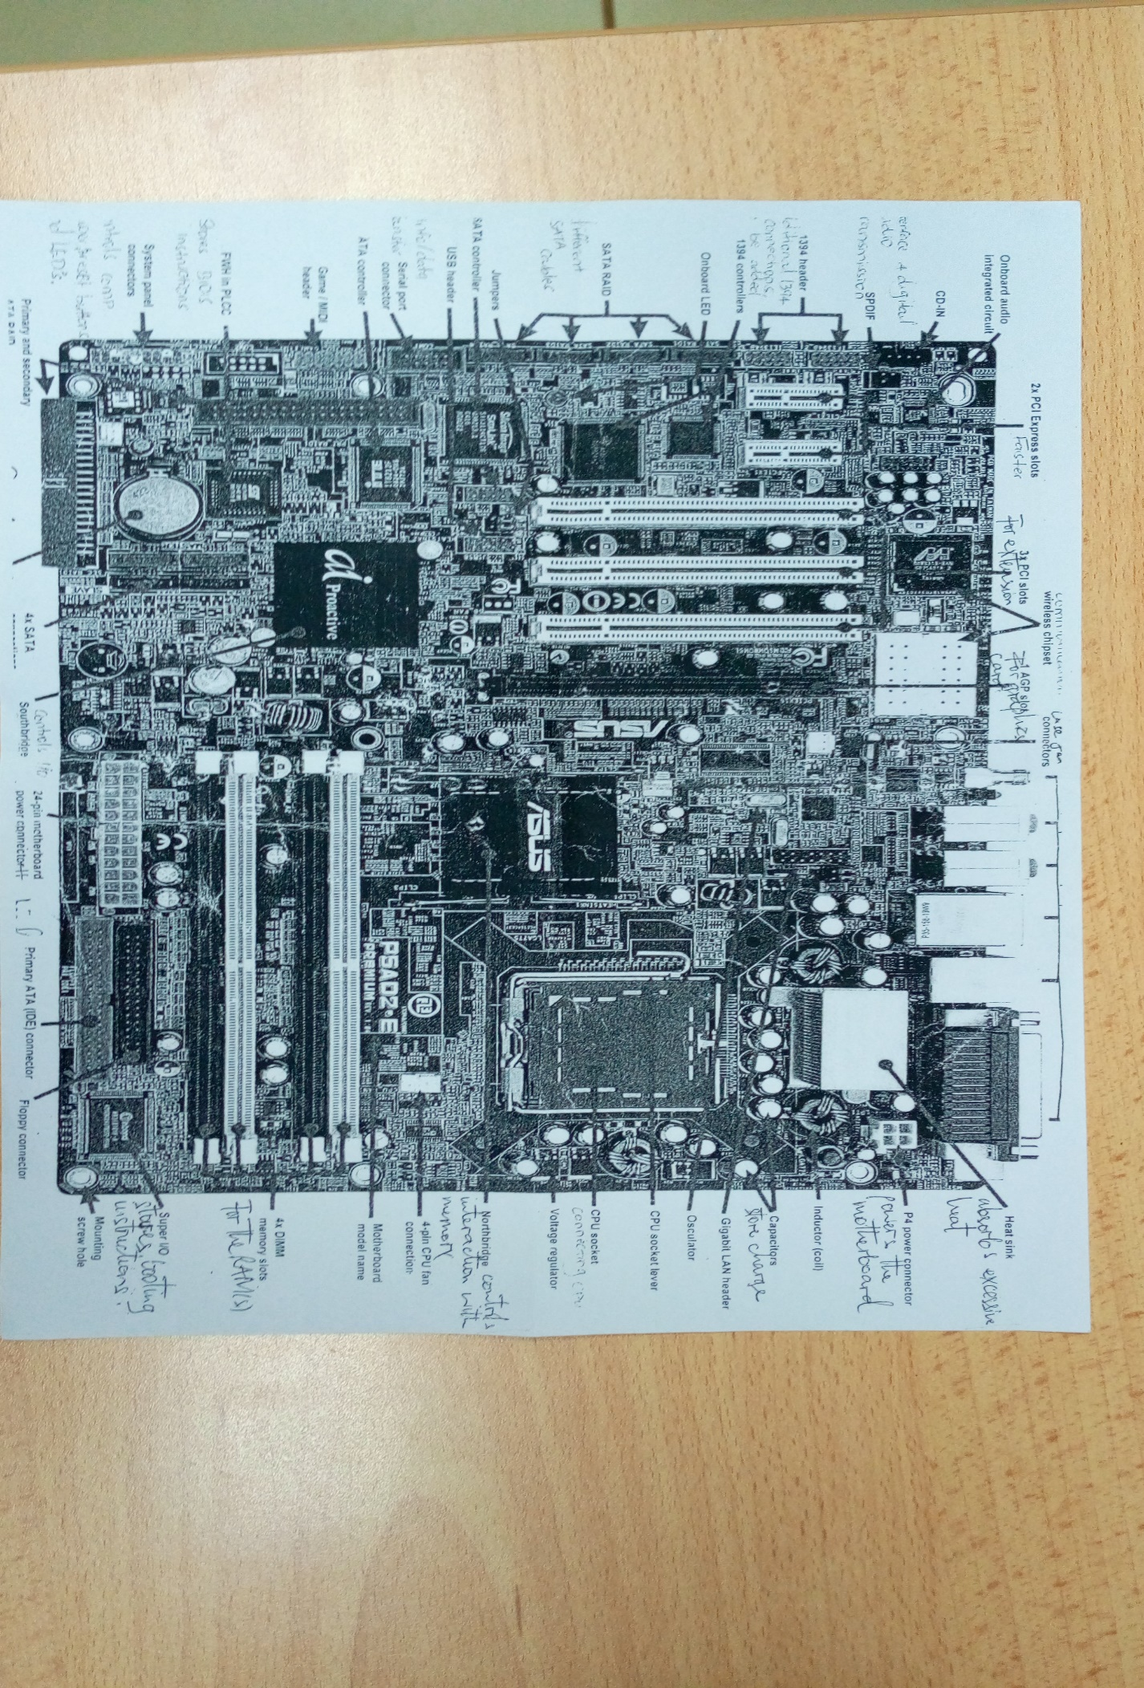

Fig.4 8086 kit

**END**